Scope of WORK (SOW)

ETHIX-Investment System

Funds Management Scope Document

**Author:** ITS

**Filename:** SOW- *Fund Management Document Scope of Work*

**Revision Date:** June 13, 2013

**Version:** 1.0

NOTICE

This document constitutes confidential information of International Turnkey Systems (ITS). By accepting this document the recipient agrees the recipient or any of the recipient’s employees or representatives to anyone therein shall disclose neither the document nor any of the information without the prior written consent of International Turnkey Systems (ITS).

Document Change History

|  |  |  |  |
| --- | --- | --- | --- |
| Author | Version | Release Dt | Release Comments |
| Sameh Reda | 1.0 | June 13, 2013 |  |
|  |  |  |  |
|  |  |  |  |
|  |  |  |  |
|  |  |  |  |
|  |  |  |  |
|  |  |  |  |
|  |  |  |  |
|  |  |  |  |
|  |  |  |  |
|  |  |  |  |
|  |  |  |  |
|  |  |  |  |

Document Sign Off

|  |  |  |
| --- | --- | --- |
| Date | NAme | Signature |
|  |  |  |
|  |  |  |
|  |  |  |
|  |  |  |
|  |  |  |
|  |  |  |
|  |  |  |
|  |  |  |
|  |  |  |
|  |  |  |

Table of Contents

1. Contacts and References 4

1.1 General 4

1.2 Contacts 4

1.3 References 4

2. Business Requirement 5

2.1 Business Summary: 5

2.2 Detail Requirements 5

2.3 <Process Flow Diagram> 19

2.4 Design and implementation constraints 19

2.5 User Documentation 20

2.6 Assumptions 20

2.7 Dependencies 20

2.8 Technical Business Requirement 21

2.8.1 Field Definitions 21

2.8.2 Exchange Rate & commissions 21

2.8.3 Functions Rules 21

2.8.4 Advices 21

2.8.5 Total Update 22

2.8.6 Accounting entries 22

2.9 Data Migration Requirements 22

2.10 Interface Requirements 22

2.10.1 Hardware Interface 22

2.10.2 Software Interface 22

2.10.3 Communication Interface 22

2.11 Report Requirements 22

2.12 Training Requirements 22

2.12.1 Customer Training 22

2.12.2 ITS Training 22

2.13 Additional Business Requirements 22

3. Required Features 23

3.1 <Feature Name> 24

3.1.1 Description and Priority 24

3.1.2 Stimulus / Response Sequences 24

3.1.3 Functional Requirements 24

3.1.4 Acceptance Test Criteria 24

4. Non Functional Requirements 25

4.1 Performance requirements 25

4.2 Safety Requirements 25

4.3 Security Requirements 25

4.4 Software Quality Attributes 25

5. Test Cases 26

5.1 Test Scenarios 26

6. Cost 27

7. Appendix 29

7.1 Appendix A: Business Rules 29

7.2 Appendix B: Formulas and calculations 29

7.3 Appendix C: Examples 29

7.4 Appendix D: Glossary 29

8. Correspondence 30

8.1 << Type Comment Short Description Here >> 30

# Contacts and References

## General

|  |  |
| --- | --- |
| **Issue #:** |  |
| **Subject:** |  |
| **Client Name:** |  |
| **Submitted By:** |  |

## Contacts

|  |  |  |  |
| --- | --- | --- | --- |
| List of individuals whom may contact for information about this requirement. | | | |
| Name | Title | Phone Number | Email |
| Sameh Reda | Sr. Functional Specialist | +96550211595 | Sameh.reda@ITS.WS |
|  |  |  |  |
|  |  |  |  |
|  |  |  |  |
|  |  |  |  |

## References

|  |  |
| --- | --- |
| List documents or references supporting this business requirement. (If a regulatory requirement, please include a copy of the regulation. If this business requirement is to support specific financial calculations please provide a copy of the calculations.) | |
| Document / Reference | Comments |
|  |  |
|  |  |
|  |  |
|  |  |

# Business Requirement

## Business Summary:

This Document explain the details Scope of work for Fund Management and related operations and how it will be implemented on the system.

## Detail Requirements

**Fund Operations** required to be covered in ETHIX-Folio

* For Clients:
* Fund Subscription
* Fund Redemption
* Fund Profit Distribution to the shareholders
* For Bank:
* Fund Subscription
* Fund Redemption
* Fund Profit Distribution
* Evaluation

**System Setup**

* **Product Setup**

Starting point on the system will be by creating 3 product of type fund; each product will hold the following details

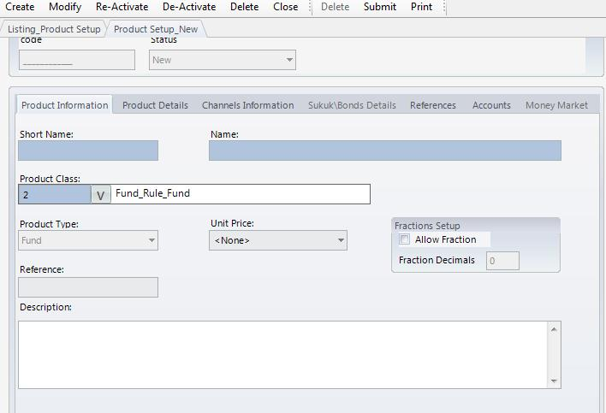

1. Product Name
   1. Al-Aman Fund
   2. Faisal Fund
   3. Misr El Khair Fund
2. Product Class
   1. Funds Owned by FIB
   2. Fund not owned by FIB
3. Product Type
   1. Fund
4. Currency: EGP
5. Country: Egypt
6. Face Value:
7. Market Volume: (user will input the capital of the fund)
8. Custodian: (user will select the custodian of each fund)
9. Sector
10. Classification
11. Accounting Classification
    1. Available for sale
    2. Held for trading
    3. Held till maturity
12. Paying Agent
13. Depository Agent
14. Units In Fractions: (Yes/No) if yes then user must define number of fractions

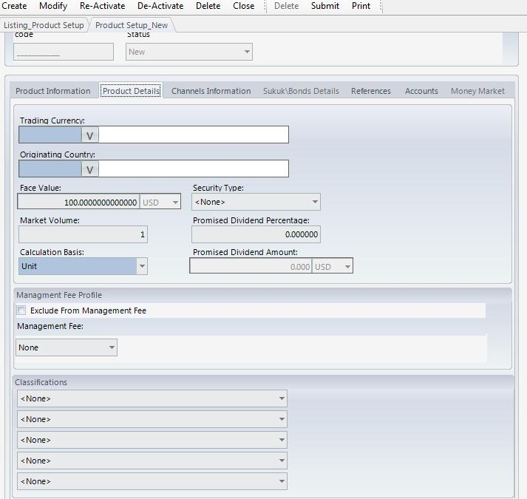

* **Portfolio Setup**

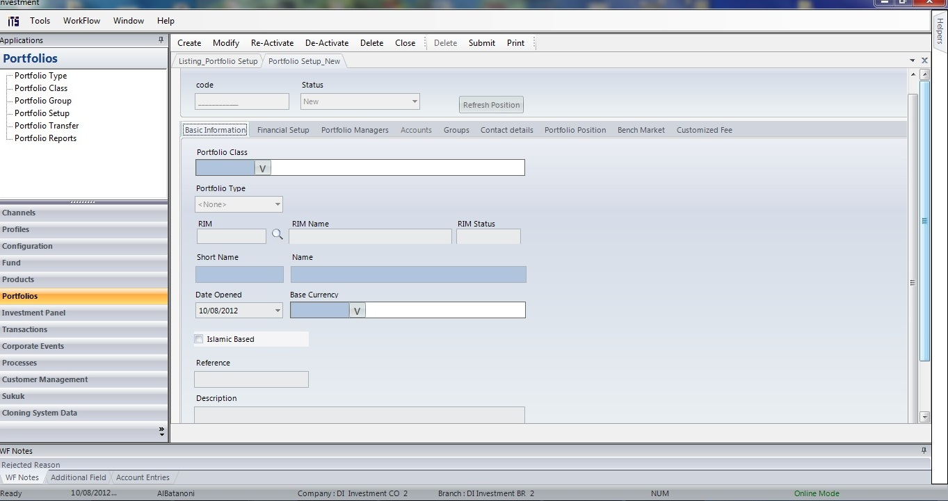

As Standard in the system All operations that will be executed by ETHIX-Folio will be done using a portfolio

So the 1st step is to create portfolio for each customer and one portfolio for the bank (FIB)

Portfolio Name will be the same name of the Customer with a link with a primary owner (Rim Number)

Portfolio setup will hold the following information

1. Portfolio Short name
2. Portfolio Name
3. Portfolio Class
4. Portfolio Type
5. Rim: (owner of portfolio)
6. Open Date:
7. Islamic Based: (Yes/No)
8. Portfolio Accounts(GLS)
   1. Funds GL
   2. Realized Gain And Loss
   3. Portfolio Cash Account
   4. Cash Dividend Income Account
   5. Cash Dividend Receivable Account

***Business Cycle of Fund Subscription for the Customer (Summary):***

In order to handle the Fund Subscription For Customer the following steps need to be done as a Workflow

1. Cash Transfer to Intermediate account will be executed on (Ethix – Branch Module)
2. Cash Deposit transaction will be done on Client Portfolio on Treasury Module using the intermediate Account
3. Once the NAV published then Trade Buy (Subscription) transaction will be done on the system for the portfolio of the customer (Treasury Module)
4. Once the trade approved in the system then the Interface files will be generated from the system (Treasury Module)
5. Once the trade approved also a report can be printed from the system to print all trades subscriptions done during the selected period (Treasury Module)
6. Cash deposit transaction will be done to affect Fund Manager Current account on (Ethix – Branch Module)by the total amount of Subscriptions

***Business Cycle of Fund Subscription for the Customer (Details):***

1. **Cash Transfer (Ethix – Branch Module)**

This transaction will be done through Ethix-Branch Module

***Accounting Entries***

Dr / Customer Saving Account

Cr / Intermediate Account

1. **Cash Deposit**

The functionality of this transaction is to Transfer the Cash from Customer Saving account or current account or any other account To Portfolio Cash Account.

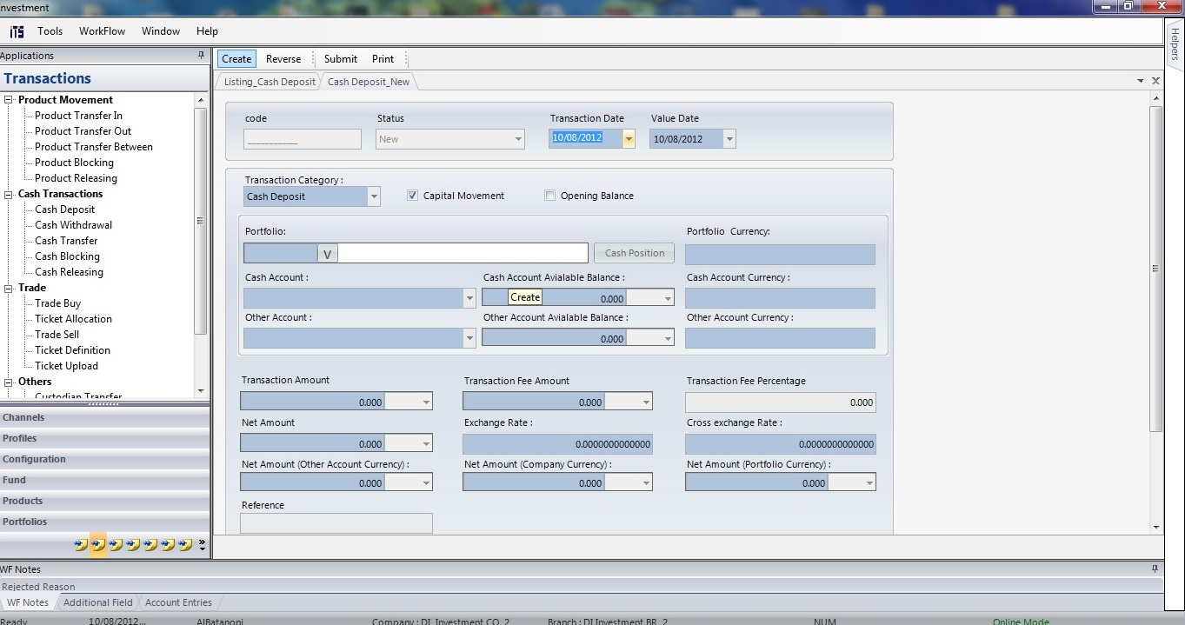

For each Cash Deposit Transaction user must fill the following data.

1. Portfolio Name
2. Amount
3. Portfolio Cash Account
4. Portfolio Capital Account

**Accounting Entries**

System will generate the following Accounting entries as a result of cash deposit transaction

Dr / Portfolio Cash Account (Off Balance Sheet)

Cr / Portfolio Capital (Off Balance Sheet)

Dr/ Intermediate Account (this account used in 1st transaction {Cash Transfer})

Cr/ Customers Subscriptions in the Fund

Note: as a result of the previous accounting entry the Intermediate Account balance will be zero

1. ***Fund Subscription (Trade Buy)***

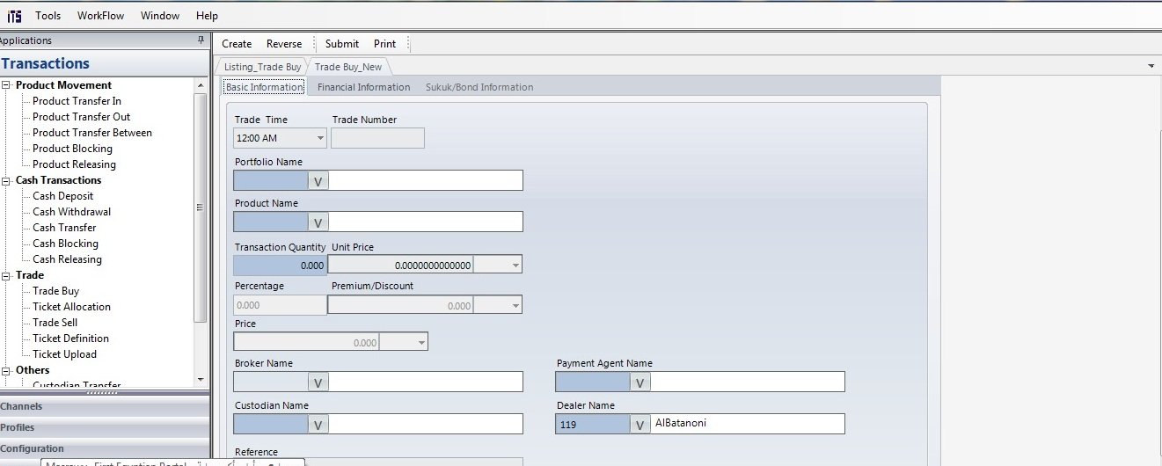

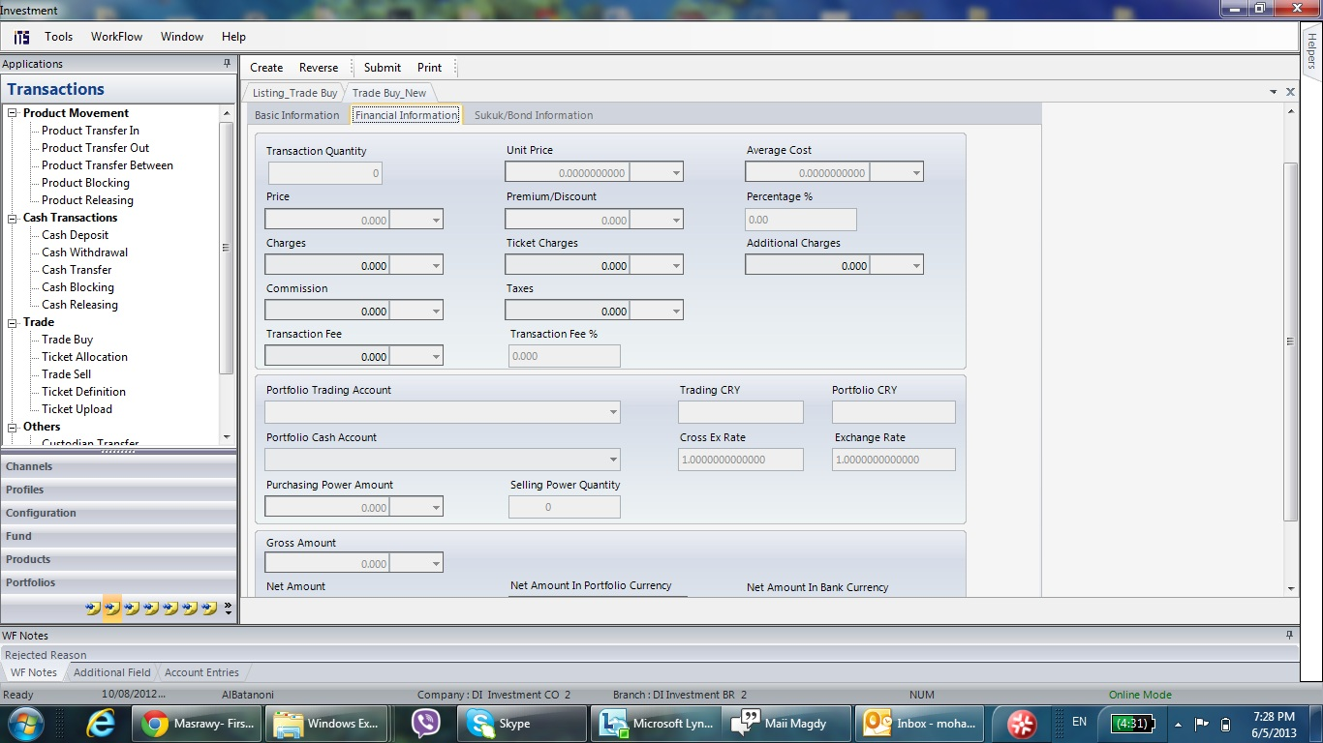

This Transaction called trade buy on ETHIX-Treasury System ,and will be used as Fund subscription transaction where user will input the following Information

1. Portfolio Name: (Client Name) user will select one portfolio for each transaction ,
2. Product Name: (Fund Name) user will select one of 3 funds Available
3. Custodian
4. Broker
5. Paying Agent
6. Quantity
7. Unit Price
8. Gross Amount : System will calculate (3*4)
9. Transaction Fees: user will input or system will calculate
10. Net Amount: (5+6)
11. Portfolio Cash Account :system will select the default or user can change

**Accounting Entries**

As a result of Subscription transaction system will pass the following Accounting Entries

Dr/ Fund Investment (Off Balance)

Cr/ Portfolio Cash Account (Off Balance)

Dr/ Customers Subscriptions in the Fund (On Balance sheet A,E)

Cr/ Intermediate Account 2 (On Balance sheet A,E)

Cr/ Fees Income (On Balance sheet A,E)

Note:

* as a result of the previous accounting entry Customers Subscriptions in the Fund balance will be zero
* User can get a report showing all the Subscription done during the day then user will send a request to the branch to affect Fund Current Account in the bank by total subscription amount

1. ***Manual Accounting Entry***

* After executing all subscriptions on Ethix- Treasury user can get a report showing all subscriptions done during the selected period
* User will pass manual accounting entry to transfer the subscriptions amounts from (Intermediate Account 2) to Fund Pool Intermediate account

**Accounting Entry**

Dr / Intermediate Account 2(On Balance sheet A,E)

Cr / Fund Pool Intermediate account (On Balance sheet A,E)

1. ***Cash Deposit on ETHIX-Branch***

* Fund Department will inform the Branch(Giza) to execute a cash deposit transaction for the fund manager Current Account

**Accounting Entry**

Dr / Fund Pool Intermediate account

Cr / Customer Current account

**Fund Subscription Structure**

***General Rules:***

* No Trades (Subscription or redemption) will be entered on the system unless the user knows the NAV or unit price
* No interface files will be generated from the system unless the trades (Subscription or redemption) are approved in the system

***Business Cycle of Fund Redemption for the Customer (Summary):***

In order to handle the Fund redemption For Customer the following steps need to be done as a Workflow

1. Customer will ask for a redemption and branch employee will send a request to Fund department manually
2. Once the NAV published then Trade Sell (redemption) transaction will be done on the system for the portfolio of the customer (Treasury Module)
3. Once the Trade approved in the system then the Interface file will be generated from the system (Treasury Module)
4. Once the trade approved also a report can be printed from the system to print all trades redemption done during the selected period (Treasury Module)
5. Cash withdrawal transaction will be done to affect Customer portfolio cash Current account on (Ethix – Treasury Module)by the net amount of redemption
6. Cash withdrawal transaction will be don on (ETHIX-Branch Module) to deduct the amount from Fund Manager Current account
7. Cash Deposit transaction will be done on (ETHIX-Branch Module) to deposit the money in customer saving account

***Business Cycle of Fund Redemption for the Customer (Details):***

1. ***Fund Redemption (Trade sell)***

Once the NAV published then Trade sell will done on the system (ETHIX-Treasury) on the level of customer portfolio with entering the following information

1. Portfolio Name: (Client Name) user will select one portfolio for each transaction ,
2. Product Name: (Fund Name) user will select one of 3 funds Available
3. Quantity
4. Unit Price
5. Gross Amount : System will calculate (3*4)
6. Transaction Fees: user will input or system will calculate
7. Net Amount: (5-6)
8. Portfolio Cash Account :system will select the default or user can change

**Accounting Entries**

As a result of Redemption transaction system will pass the following Accounting Entries

Dr/ Portfolio Cash Account (Off Balance)

Cr/ Fund Investment (Off Balance)

Dr or Cr / Realized Gain and loss (Off Balance)

Dr/ Intermediate Account 2 (On Balance sheet A,E)

Cr/ Customers Redemptions in the Fund (On Balance sheet A,E)

Cr/ Fees Income (On Balance sheet A,E)

Note:

* as a result of the previous accounting entry Customers Redemptions in the Fund balance will be zero
* User can get a report showing all the Subscription done during the day then user will send a request to the branch to affect Fund Current Account in the bank by total subscription amount

1. ***Cash Withdrawal From Customer portfolio***

This transaction will be done on ETHIX-Treasury to withdrawal the money from Customer Portfolio to Intermediate Account.

Each redemption transaction will be having its withdrawal transaction

**Accounting Entries**

Dr / Portfolio Capital (Off-balance sheet A.E)

Cr / Customer Cash Account (Off-balance sheet A.E)

Dr / Customers Redemptions in the Fund (On balance sheet A.E)

Cr / Intermediate Account 1 (On balance sheet A.E)

1. ***Cash Deposit into Customer Saving Account (ETHIX-Branch)***

Same withdrawal amount that deducted from client portfolio will be transferred to his saving account by cash deposit transaction on (ETHIX-Branch)

**Accounting Entries**

As a result of previous transaction system will generate the following A.E

Dr/ Intermediate Account 1

Cr/ Customer Saving Account

1. ***Manual Accounting Entry***

* After executing all Redemption on Ethix- Treasury user can get a report showing all Redemption done during the selected period
* User will pass manual accounting entry to transfer the Redemption amounts from (Intermediate Account 2) to Fund Pool Intermediate account

**Accounting Entry**

Dr / Fund Pool Intermediate account (On Balance sheet A,E)

Cr / Intermediate Account 2(On Balance sheet A,E)

1. ***Cash Deposit on ETHIX-Branch***

* Fund Department will inform the Branch(Giza) to execute a cash deposit transaction for the fund manager Current Account

**Accounting Entry**

Dr / Customer Current account (Fund Manager)

Cr / Fund Pool Intermediate account

Note: as a result of the previous accounting entry Fund Pool Intermediate account balance will be zero

**Fund Redemption Structure**

***Business Cycle of Fund Profit Distribution (Summary):***

In order to implement this Fund Profit Distribution on ETHIX-Treasury there are two types of transactions must be executed as the following

* Cash Dividend Declaration: will be done once the FUND manager announce the declaring of the dividend
* Cash Dividend Collection: will be done once the fund manager transfer the dividend to the Bank to be distributed on the customers

Cash Dividend transaction can be done by

* Total Amount

**Description**: user will enter the total dividend amount of all customers subscribed in the fund and system will distribute the mount in prorate equation as the following

Dividend amount for each customer =

* Percentage

**Description**: user will enter the Dividend % then system will calculate the dividend amount for each customer as per the following formula

Dividend amount for each customer =

* Amount per Share

**Description:** User will input the amount per share then system will calculate the dividend for each customer as per the following formula

Dividend Amount for each customer =

***Business Cycle of Fund Cash Dividend for the Customer (Details):***

1. ***Fund Cash Dividend Declaration***

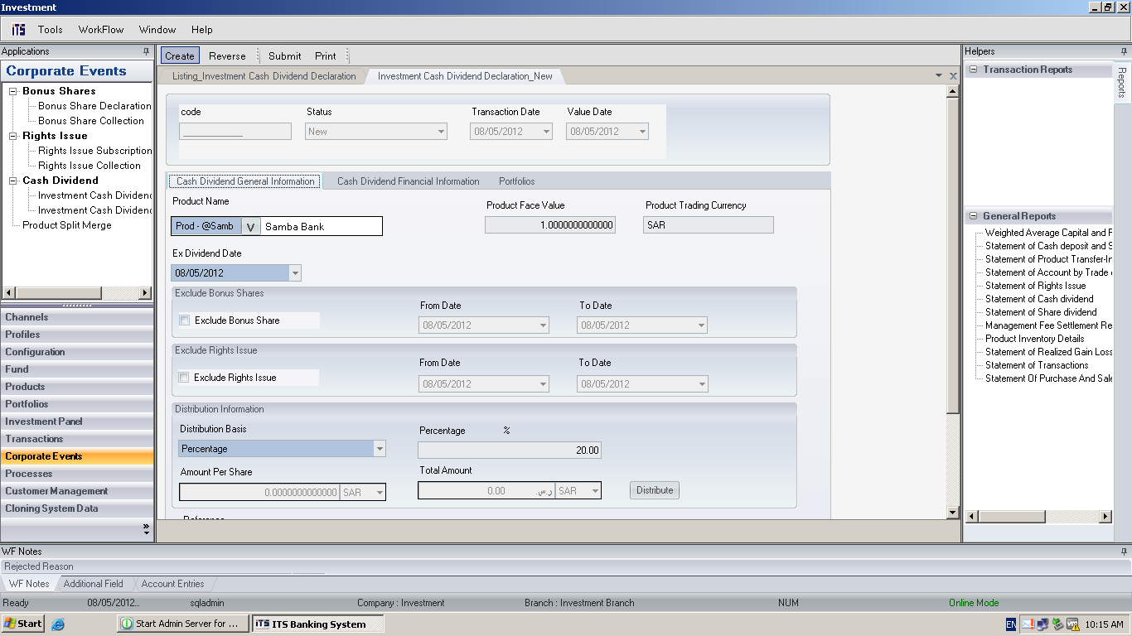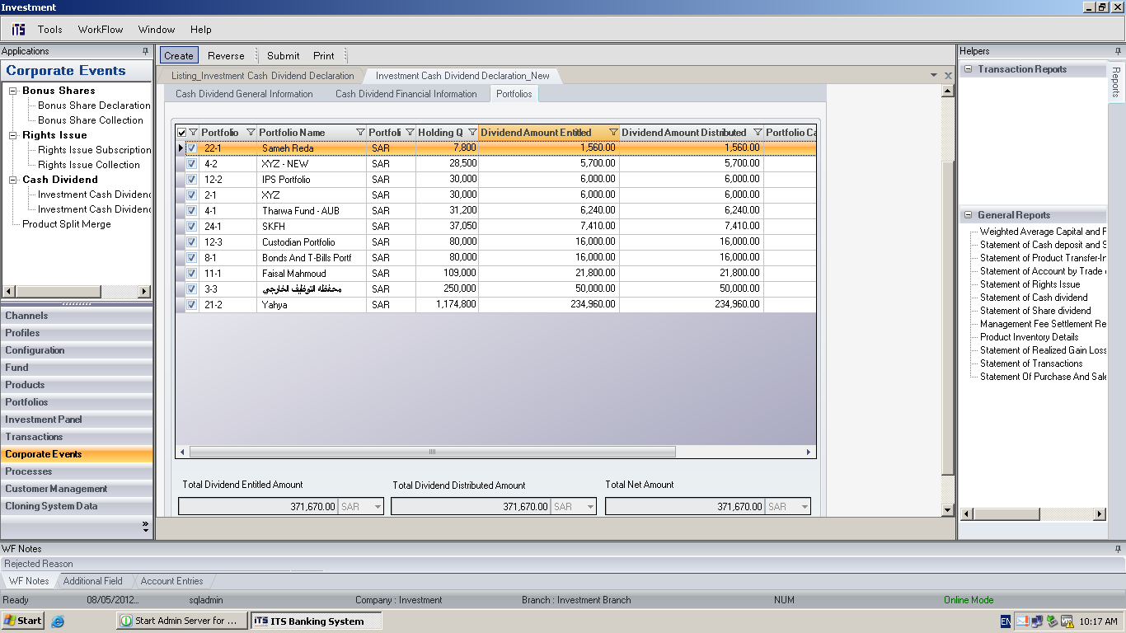

In order to create cash dividend declaration user must enter the following data

1. Product Name: (Fund Name) user will select one of 3 funds Available
2. Ex-Dividend Date: user will write the announcement date for cash dividend
3. Distribution Basis: user will select one of choices
   1. Percentage
   2. Amount per share
   3. Total Amount

**Accounting Entries**

As a result of cash dividend declaration transaction system will pass the following Accounting Entries

Dr/ Customers Dividend Receivables (Off Balance)

Cr/ Customers Dividend Income (Off Balance)

1. ***Cash Dividend Collection***

This transaction will be done on once the Fund manager distributed the dividend amount

**Accounting Entries**

Dr / Portfolio Cash Account (Off-balance sheet A.E)

Cr / Customer dividend Receivable (Off-balance sheet A.E)

**Fund Cash Dividend Structure**

***Business Cycle of Fund Subscription & redmeption for the Bank (Summary):***

The same business mentioned above for fund subscription for the customer will be implemented here with a small modification hence the processes and transactions are the same but the only different that the bank is not a customer go to branch asking for a subscription or redemption

At the initial stage new portfolio will be created by the name of the bank then the following steps will be done on the level of Bank Portfolio

1. Once the NAV published then Trade Buy (Subscription) transaction will be done on the system for the portfolio of the customer (Treasury Module)
2. Once the trade approved in the system then the Interface file will be generated from the system (Treasury Module)
3. Once the trade approved also a report can be printed from the system to print all trades subscriptions done during the selected period (Treasury Module)
4. Cash deposit transaction will be done to affect Fund Manager Current account on (Ethix – Branch Module)by the total amount of Subscriptions

***Business Cycle of Fund Subscription & Redemption for the Bank (Details):***

1. **Trade Buy (Subscription)**

**Accounting Entries**

System will generate the following Accounting entries as a result of cash deposit transaction

Dr/ Fund Investments

Cr/ Central Bank

1. **Trade Sell Redemption**

**Accounting Entry**

Dr / Central Bank

Cr / Fund Investments

Cr/Dr Realized Gain and loss

Note: if the amounts of subscription and redemption will be transferred to Fund manager current account then the same structure explained for client will be executed for those trades also (sending invoice to Giza Branch to deposit money in Fund Manager Current account) and in this case the accounting entries will be changes

1. **Cash Dividend Declaration**

**Accounting Entry**

Dr / Dividend Receivables

Cr / Dividend Income

1. **Funds Evaluation**

Will be done through FMV (Fair market valuation) process where user will the process then system automatically will run the accounting entries

**Accounting Entry**

If Loss and Investment type = Available for Sale then

Dr/ Reserve Fair Value

Cr/ Fund Investment

If Profit and Investment type = Available for Sale then

Dr/ Fund Investment

Cr/ Reserve Fair Value

1. **Taxes and coupons**

Will be part of back office activities

1. **Fund Management fees , custody fees , incentive fees**

Will be done through manual accounting entries

## <Process Flow Diagram>

|  |
| --- |
| **Process Summary:** |
|  |

|  |  |
| --- | --- |
| Define the business process, rules and condition, include any information needed for the process | |
| **Ref. No.** | **Process with Rules** |
| 2 |  |

## Design and implementation constraints

|  |  |
| --- | --- |
|  |  |
|  |  |
|  |  |

## User Documentation

|  |  |
| --- | --- |
| UD-1 |  |
|  |  |

## Assumptions

|  |  |
| --- | --- |
|  |  |
|  |  |
|  |  |
|  |  |

## Dependencies

|  |  |
| --- | --- |
|  |  |
|  |  |
|  |  |
|  |  |

## Technical Business Requirement

### Field Definitions

|  |  |  |  |  |
| --- | --- | --- | --- | --- |
|  |  |  |  |  |
|  | | | | |
|  |  |  |  |  |
|  |  |  |  |  |
|  |  |  |  |  |
|  |  |  |  |  |
|  | | | | |
|  |  |  |  |  |
|  |  |  |  |  |
|  |  |  |  |  |
|  |  |  |  |  |

### Exchange Rate & commissions

NA

### Functions Rules

### Advices

### Total Update

### Accounting entries

NA

## Data Migration Requirements

NA

## Interface Requirements

NA

### Hardware Interface

|  |  |
| --- | --- |
| HI-1 |  |
|  |  |

### Software Interface

|  |  |
| --- | --- |
| SI-1 |  |
| SI-2 |  |
| SI-3 |  |

### Communication Interface

|  |  |
| --- | --- |
| CI-1 |  |
|  |  |

## Report Requirements

## Training Requirements

### Customer Training

### ITS Training

## Additional Business Requirements

NA

# Proposed Solution:

## Proposed Solution Description:

## Proposed Solution Estimation:

# Required Features

NA

|  |  |
| --- | --- |
| FE-1 |  |
| FE-2 |  |
| FE-3 |  |
|  |  |

## <Feature Name>

NA

### Description and Priority

NA

### Stimulus / Response Sequences

NA

### Functional Requirements

NA

|  |  |
| --- | --- |
| **Function** | **Description** |
|  |  |
|  |  |

### Acceptance Test Criteria

NA

|  |  |
| --- | --- |
| ATC-1 |  |
| ATC-2 |  |
|  |  |

# Non Functional Requirements

NA

## Performance requirements

NA

|  |  |
| --- | --- |
| PE-1 |  |
|  |  |

## Safety Requirements

NA

|  |  |
| --- | --- |
| SA-1 |  |
|  |  |

## Security Requirements

NA

|  |  |
| --- | --- |
| SE-1 |  |
|  |  |

## Software Quality Attributes

NA

|  |  |
| --- | --- |
|  |  |
|  |  |

# Test Cases

## Test Scenarios

# Cost

|  |  |  |  |  |  |
| --- | --- | --- | --- | --- | --- |
| CR accepted as baseline 2 for sizing  CR accepted for baseline 3 analysis  CR to be delivered as a Professional Service  CR Rejected | | | | | |
| **ITS PM/Pre-Sales (signature):** | | |  | | |
| **Baseline 3 Analysis of requirement ( conduct analysis to point of clarity)** | | | | | | |
| **Functional (product) Requirements \*** | ***Effort type: Developmeznt/Customization/Parametorization [D/C/P] \**** | | | | | |
|  | | | | | | |
| **Non-Functional (Process) Requirements** * | | | | | ***Effort type: D/C/P \**** | |
|  | | | | | | |
| **Migration Requirements \*** | ***Effort type:D/C/P \**** | ***Tech Risk: H/M/L*** | | | ***Project Risk: H/M/L*** | |
|  | | | | | | |
| **Interface Requirements \*** | ***Effort type:D/C/P \**** | ***Tech Risk: H/M/L*** | | | ***Project Risk: H/M/L*** | |
|  | | | | | | |
| **Business Process Flow Requirements \*** | ***Effort type:D/C/P \**** | ***Tech Risk: H/M/L*** | | | ***Project Risk: H/M/L*** | |
|  | | | | | | |
| **Requirement for Reports \*** | ***Effort type:D/C/P \**** | ***Tech Risk: H/M/L*** | | | ***Project Risk: H/M/L*** | |
|  | | | | | | |
| **Training Requirements \*** | ***Type: Formal/In Formal/ On The Job*** | | | ***Location: Customer Site/ ITS/Other*** | | |
|  | | | | | | |
| **Other Requirements \*** | ***Effort type:D/C/P \**** | ***Tech Risk: H/M/L*** | | | ***Project Risk: H/M/L*** | |
|  | | | | | | |

|  |  |  |  |  |  |  |  |  |  |  |  |  |  |  |  |
| --- | --- | --- | --- | --- | --- | --- | --- | --- | --- | --- | --- | --- | --- | --- | --- |
| **Sizing for proposed solution** | | **Days/Hrs** | | | **Cost** | **Period** | | | **Expenses and Comments** | | | | | | |
| Effort to design/build /test solution | |  | | |  |  | | |  | | | | | | |
| Effort to produce documentation | |  | | |  |  | | |  | | | | | | |
| Other: | |  | | |  |  | | |  | | | | | | |
| Estimated by: | | | | | | | | | | | Date: | | / / | | |
| BSD effort to design/deliver training | |  | | |  |  | | |  | | | | | | |
| BSD effort to implement solution | |  | | |  |  | | |  | | | | | | |
| Estimated by: | | | | | | | | | | | Date: | | / / | | |
| CSD effort to implement infrastructure | |  | | |  |  | | |  | | | | | | |
| CSD support costs after warranty | |  | | |  |  | | |  | | | | | | |
| Estimated by: | | | | | | | | | | | Date: | | / / | | |
| Sales License costs | |  | | |  |  | | |  | | | | | | |
| Total costs | |  | | |  |  | | |  | | | | | | |
| Sales selling price | | | | | | | | | | | | | | | |
| Given by: | |  | | | | | | | | | Date: | | / / | | |
| ITS Follow-Up with customer: | | | | | | | | * √ or delete as required | | | | | | | |
| After initial analysis, CR not accepted | | PM authorized CR as no change of Scope or Schedule Baseline | | | | | | | | | | | | |  |
| PM: | presented CR proposal to customer | | | | | | *Accepted | | | | | In/out of project? *In/ Out | | | |
| Region Representative: | *Rejected | | | | |
| ITS PM/ Region Representative Signature: | | | | | |  | | | | | Date: | | | / / | |
| ITS PM/ Region Representative Follow-Up Action: | | | |  | | | |  | |  | | | | | |
| Help Desk informed of CR status change by: | | |  | | | | | | | | Date: | | | / / | |
| CR forwarded to Help Desk by: | | |  | | | | | | | | Date: | | | / / | |

# Appendix

## Appendix A: Business Rules

|  |  |  |  |  |
| --- | --- | --- | --- | --- |
| **ID** | **Rule Definition** | **Type of Rule** | **Static or Dynamic** | **Source** |
| BR-1 |  |  |  |  |
| BR-2 |  |  |  |  |
| BR-3 |  |  |  |  |

## Appendix B: Formulas and calculations

## Appendix C: Examples

Excel Sheet attached explain Charges Profile Chagres Profile and Penalty Profile

## Appendix D: Glossary

# Correspondence

This section should be used for correspondence between ITS and the primary stakeholder to discuss questions or make comments or suggestions to the contents of the Functional Requirements document. Use the table below for this purpose.

## << Type Comment Short Description Here >>

|  |  |
| --- | --- |
| **FRID / Section ID:** |  |
| **Post** | |
| **Initials:** | <initials> |
| **Date:** | <dd/mm/yyyy> |
| <Post your comments here> | |
| **Reply** | |
| **Initials:** | <initials> |
| **Date:** | <dd/mm/yyyy> |
| <Reply to posted comments here> | |